Time Varying Fields Homework (29 Points)
(jas Time Varying Fields HW.docx 11/12/2025)

Use units and clearly label answers using 3 or 4 significant digits where appropriate. Show your work so that if necessary partial credit can be awarded.


- Using your own words and complete sentences along with Lenz’s law, explain why a permanent magnet falling through the center of a vertical copper pipe, as illustrated in the adjacent figure, falls slower than if the pipe was made of a non-conductive material such as PVC plastic.
(5 points.)

Lenz’s law says that when a current is induced in a conductor, the magnetic field that the current produces is opposite of field that initially produced the current. As the magnet falls, it induces a current in the conductor, and this current produces a new magnetic field. The initial magnetic field is downwards, and the new magnetic field is upwards. This means that the magnet will fall slower than it would without the pipe, because there is an opposite force on the magnet slowing it down.

- Using your own words and complete sentences, explain why an inductor oppose a change in current. (2 points.)

An inductor is essentially a wire round in tight circles. When a current passes through an inductor, the magnetic field it produces is perpendicular to the ends of the inductor. The magnitude of this magnetic field is dependent on the amount of current flowing through the inductor. So, when the current changes, so does the magnitude of the magnetic field. Faraday’s law says that a changing magnetic field induces a voltage. This voltage is opposite of the direction of current flow in the inductor. Because of this, the induced voltage opposes the change in current flow.

- Using your own words and complete sentences, explain what Maxwell’s Equation $\text{∇×}\text{E}\text{ =-}\frac{\text{∂}\text{B}}{\text{∂t}}$ expresses about electric fields (2 points). Include some remarks distinguishing the electric field lines associated with $\text{∇×}\text{E}\text{ =-}\frac{\text{∂}\text{B}}{\text{∂t}}$ (1 point) in comparison with the electric field lines associated with static electrical charges (1 point).
(4 points total.)

$∇×E=-\frac{∂B}{∂t}$ is Faraday’s Law of induction, which states that a changing magnetic field over time induces a circulating electric field. So, the rate of change of the meagnetic field is equal to the induced electric field negated. This means that the field has a curl, apposed to the electric field lines associated with static electrical charges, which have no curl. Induced electric fields form closed loops, which electric fields from static charges radiate inward or outward.

- Using your own words and complete sentences, explain what Maxwell’s Equation $\text{∇×}\text{H}\text{ = }\text{J}\text{+}\frac{\text{∂}\text{D}}{\text{∂t}}$ expresses about magnetic fields, referred to in the class notes as the Ampere-Maxwell Law. (2 points.)

This equation expresses magnetic fields are created in two ways: electric currents (J), or changing electric fields ($\frac{∂D}{∂t}).$ The combination of this law and Faraday’s Law means is what allows electromagnetic waves to exist, and even travel through the vacuum of space without a medium, because a magnetic field induces an electric field, and an electric field induces a magnetic field.

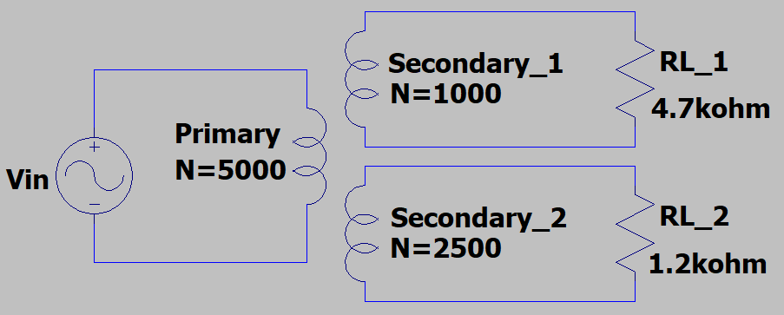
- The adjacent schematic represents an ideal transformer with two secondary windings and associated load resistances. Determine the resulting input resistance R_{in} = V_{in}/I_{in} at the primary terminals. (Hint: Consider each secondary separately and combine the results appropriately. Check your answer by means of a primary and secondary power comparison for an ideal transformer). (6 points.)

$$Z_{in}={\left(\frac{N_{1}}{N_{2}}\right)}^{2}Z_{L}$$
Secondary 1: $R_{in1}={\left(\frac{5000}{2500}\right)}^{2}\left(4.7kΩ\right)=117.5 kΩ$
Secondary 2: $R_{in2}={\left(\frac{5000}{2500}\right)}^{2}\left(1.2kΩ\right)=4.8kΩ$
$R_{in}=\frac{R_{in1}*R_{in2}}{R_{in1}+R_{in2}}=4.610kΩ$
$$R_{in}=4.610kΩ$$

- An AC generator with armature loop area of 0.1 m² and 20 turns, rotates the armature at 60 Hz within a static magnetic field with magnetic flux density of 0.2 T.
- Using $V_{emf}^{m}=NAωB_{0}sinωt$, include below the appropriate numeric expression for $V_{emf}^{m}$ as a function of time including units. (Hint: The peak emf voltage should be between 140 and 160 V.) (2 Points.)
$$V_{emf}^{m}=NAωB_{0}sin(ωt)$$
$$N=20 turns;A=0.1m^{2};f=60 Hz;ω=2πf=120π; B_{0}=0.2T$$
$$V_{emf}^{m}=\left(20\right)\left(0.1\right)\left(120π\right)\left(0.2\right)sin\left(120πt\right)$$
$V_{emf}^{m}=150.80sin(377.0t)$

- Using MATLAB, plot the $V_{emf}^{m}$ expression derived for part (a.) for time t ranging from 0 to 20 ms in 100 µs increments along the x-axis. On your plot scale the x-axis so that the time is displayed in units of milliseconds rather than seconds. Include both x and y axis labels with units, along with the title “AC Generator Output Voltage – Your Name”. (8 Points.)

